Real-Time River Water Quality Monitoring and Control System

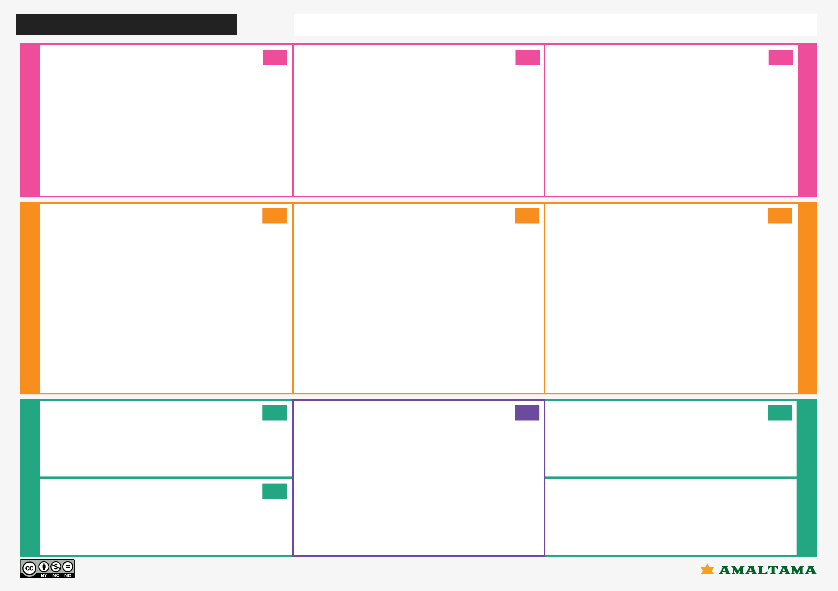

People'sPurposand wae / teVirsiquaon lity OfficersPeople's and water quality Officers

TEAM ID:PNT2022TMID07826

1. **CUSTOMER SEGMENT(S)**

Who is your customer?

i.e. working parents of 0-5 y.o. kids

**Define CS, fit into CC**

**CS 6. CUSTOMER CONSTRAINTS CC 5. AVAILABLE SOLUTIONS AS**

What constraints prevent your customers from taking action or limit their choices Which solutions are available to the customers when they face the problem of solutions? i.e. spending power, budget, no cash, network connection, available devices. or need to get the job done? What have they tried in the past? What pros & cons do

these solutions have? i.e. pen and paper is an alternative to digital notetaking

*People's and water quality Officers

**Explore AS, differentiate**

**Foc us**

**B E**

*The head office should monitor the surroundings of River Water weakly once

*Network availability and available device are the biggest issue face by the customers and need to spend a time to get daily update.

*The solution is to avoid the mixing of industrial waste.

*Strom water management.

*Waste water treatment.

* 1. **BEHAVIOUR BE**

|  |  |  |  |  |  |  |  |  |
| --- | --- | --- | --- | --- | --- | --- | --- | --- |
| **RC** | **2. JOBS-TO-BE-DONE / PROBLEMS** | **J&P** |  |  |  | **9** | **. PROBLEM ROOT CAUSE** | **RC** |
| **Focu sonJ &P,ta pinto BE,u**  **nders** | Which jobs-to-be-done (or problems) do you address for your customers? |  |  |  |  |  | What is the real reason that this problem exists? |  |
|  | There could be more than one; explore different sides. |  |  |  |  |  | What is the back story behind the need to do this job? |  |
|  |  |  |  |  |  | i.e | . customers have to do it because of the change in regulations. |  |
|  | *To identity the water quality  *Chemical waste sometimes discharged into rivers |  |  |  |  | **1** | * The major problem is the industrial waste and chemical waste mixing into the river. * As we know sensors are bit costly and our system needs more than one sensor to work. The sensors are used periodically to check the quality of the water and might need to be replaced frequently.   **0. YOUR SOLUTION** |  |
|  | **3. TRIGGERS** | **TR** | **SL** |
| **EM** | t? i.e. seeing their neighbor installing |  |  |  |  | If | you are working on an existing business, write down your current solution first, |  |
| solar panels, reading about a more efficient solution in the news. |  |  |  |  | fil | l in the canvas, and check how much it fits reality. |  |
| **&** |  | |  |  |  | I | f you are working on a new business proposition, then keep it blank until you fill in |  |
| **strong TR** | Give awareness for monitoring the water quality to the people | |  |  |  | th | e canvas and come up with a solution that fits within customer limitations, |  |
|  |  |  | so | lves a problem and matches customer behavior. |  |
| **4. EMOTIONS: BEFORE / AFTER** | **EM** | * Recycle the river water weakly once. * We provide a good source to the public and we work based on public review. | | | | | |
| **Id en tif y** |
|  | How do customers feel when they face a problem or a job and afterwards?  i.e. lost, insecure > confident, in control - use it in your communication strategy  People felt insecure and unknowledge about the qu now they have more confident about their drinking water. | & design  ality, |

What does your customer do to address the problem and get the job done?

i.e. directly related: find the right solar panel installer, calculate usage and benefits; indirectly associated: customers spend free time on volunteering work (i.e. Greenpeace)

*Identify the Problems.

*Final better network availability calculate the quality and quantity of water.

**RCunderstandBE,intotapJ&P,on**

* 1. **CHANNELS of BEHAVIOUR CH**
     1. **ONLINE**

What kind of actions do customers take online? Extract online channels from #7

Public may provide review and rating for the system.

**ff**

* + 1. **OFFLINE**

What kind of actions do customers take offline? Extract offline channels from #7

. and use them for customer development.

By using the smart sensor, the PH level of river water is identify.

Problem-Solution it canvas is licensed under a Creative Commons Attribution-NonCommercial-NoDerivatives 4.0 license

Created by Daria Nepriakhina / Amaltama.com